ΚΔΡ Chronicle
April 2007
Consul’s Corner
Anthony DiLoreto
Consul
The Alpha Gamma chapter had a very exciting and productive semester in the fall and continues to progress into the spring. In the fall we were pleased to initiate 13 excellent new members, almost doubling the size of our chapter and once again becoming the largest fraternity on campus. We more recently initiated two more young men into our brotherhood and are pleased to see them develop into fine gentlemen. The chapter has continued its tradition of giving back to the community through our annual participation in Angel’s Night in Detroit, where we helped make it one of the safest nights in Detroit. Coming up is the Detroit Project, where thousands around Detroit will help improve the blight of the city. The chapter has been able to keep academics as one of its strongest attributes and continues to improve. Eight of our current members earned at least a 3.5 on a four-point scale in the fall term, and our overall G.P.A continues to be the highest amongst the Greek system on campus. In terms of campus involvement, nearly all members of the Alpha Gamma participate in at least two other organizations, with several members serving as President within these organizations. Also this term, the chapter continued its second year of school funded tailgating in support of the men’s basketball team. The chapter would set up a tent outside the stadium before all home games and provide free food to anyone who attended, courtesy of the school funds committee (S.E.N.S.O.G.). This event gave the chapter a chance to improve alumni and faculty relations, as numerous professors and alumni frequented the event. The chapter’s alumni corporation continues to grow and currently handles all aspects of our house and Red Rose Formal. Recently, the alumni corporation announced its first annual scholarship to be given out to a current member at our Red Rose Formal this spring. To get more information about the Alpha Gamma chapter and its members take a look at our website at http://es.udmercy.edu/~kappadeltarho/.

Service Update
Bryan Vos
Service Chairman

This winter, the brothers of Alpha Gamma kicked off the community service schedule by donating their time and a little bit of peanut butter and jelly to make lunches for homeless people. They then traveled around the city, handing out the lunches directly to the needy in an event we call “The Sandwich Bus”. This offered the brothers a way to give directly to those in need and see the blight of our neighbors and our fellow man. When the weather turned warmer, the brothers headed out to a service project with the Motor City Blight Busters. This organization is committed to demolishing blight in the city and rejuvenating the urban environment. In that spirit, the brothers were given the task of demolishing an abandoned crack house. The old crack house was demolished KDR style; nothing was left standing when we were done. During the school year, the brothers logged a total of over 200 service hours, mostly giving their time back to the urban environment in which they live in the spirit of the mission of the University of Detroit Mercy.

Rushing in Winter 2007
Alex Gallegos
Senior Tribune
This semester’s rush wasn’t as intense as the fall’s but everyone still worked together and had the same dedication. With classic events like Xochimilco’s on Wednesdays and movie night, everyone enjoyed themselves and came together this rush. The attendance at the events was an expected lower amount than the previous semester, but we crossed 2 new promising brothers: Alex Repeck, and Joe Colombo. Alpha Gamma Still stands strong in bringing quality and will continue to attract people people who live up to Honor Super Omnia.

Pledging in Winter 2007
Mark Fazi
Junior Tribune
This Winter’s Pledge Program was another success in transforming men into brothers of Kappa Delta Rho, forming a brotherhood which could not be broken, lasting forever. These privileged men were, Alex Repeck and Joe Colombo.
Through a 6-week pledge program, these men were able to see what takes to be a brother of Kappa Delta Rho. They did this by learning the history of Kappa Delta Rho and from the examples of the men before them. By interviewing each brother these new members were able to see what it takes to be Gentlemen of Kappa Delta Rho.
With this guidance and knowledge these new members will be the future leaders of Kappa Delta Rho. That is why this pledge process is so vital to the growth of this fraternity and it looks like we hit the nail on the head.

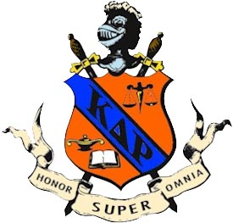

We’re On The Web!
Visit us at
http://es.udmercy.edu/~kappadeltarho

Inside This Issue
2 | Service Update  Rushing 2007  Pledging 2007
3 | ΚΔΡ Dominates Intramurals Once Again  Scholarly are we
4 | State of Affairs & Alumni Corporation

From the Desk of the Editor
R. Graham Greenland
Propraetor
This year was another mark to the many great years of Kappa Delta Rho. With the addition of two more bothers our fraternity continues to aggrandize. With the help of our alumni we hosted several exciting Titan Tailgate events, marking another great feat in the area of publicity and social activity. We close this semester with high success and anticipate the fall for another great semester.

ΚΔΡ Dominates Intramurals Once Again
Joshua A. Reiter

The Alpha Gamma chapter has enjoyed a very busy and competitive year in IM sports at UDM. The chapter participated and dominated in all IM sports, including in the new IM contests recently added to the program, placing highly in each. The boys won the flag football league, the biggest IM sport on campus, for the first time ever with an undefeated record. They represented UDM well and made a great showing at the state tournament finishing third and having a member elected to the All-Tournament Team. That wasn’t the only sport won by the Alpha Gamma Chapter; Indoor and Outdoor Volleyball were both taken by Kappa Delta Rho – both undefeated. Third place was the lowest finish we would see from Alpha Gamma – where we placed in both the basketball seasons. In dodgeball and indoor soccer we suffered heartbreaking second place finishes, both championship games were decided 'at the wire.' The KDR's were the favorite to repeat their championship in outdoor soccer as well before the season was cancelled. Team sports weren’t the only place where we succeeded: Alpha Gamma faired well in individual contests as well winning both the Home Run Derby and the Racquetball Tournament. Every member contributed to the success of the Alpha Gamma chapter signing up to participate. We had an influx of great athletes and it was always hard to narrow the roster to the set limit. Alpha Gamma even had an overwhelming number of non-brothers ask to participate with them on IM teams because of their dominance and their great sportsmanship. The KDR's always had the biggest crowd at each event of fellow brothers and friends that ensured the proud, consistent, and winning ways of the chapter.

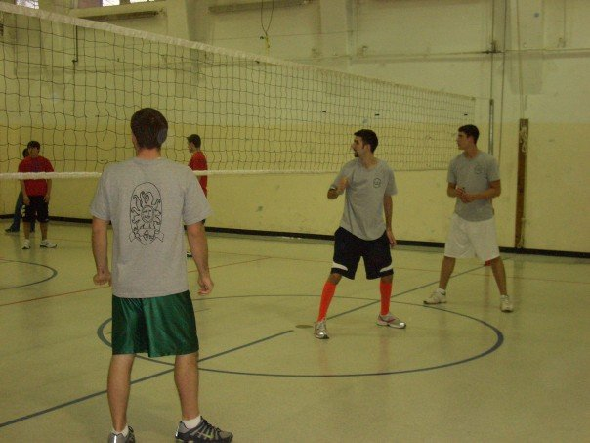

Scholarly Are We
David Powell
Scholarship Chariman
This semester our brothers showed a strong commitment to maintaining and advancing Alpha Gamma’s sterling scholastic tradition. Members, both young and old, stepped up to show their dedication to keeping our GPA the highest on campus while acting as leaders among the various organizations to which we belong. With fifteen new members this year, it was important that the veteran brothers stood as a good example of what it means to be a college student in Kappa Delta Rho. They did not disappoint. Four of our fifth year alumni completed their masters in architecture this semester, and four more seniors were accepted into graduate studies in their various concentrations. Thanks and congratulations go out to everyone on their hard work this year.

Red Rose Formal on April 13th, 2007
Red Rose Formal April 13, 2007

State of Affaris – My Outlook of the `06-07 year for Alpha Gamma
Kevin Degrood
President – Alpha Gamma Alumni Corporation
This year saw many changes for the Alpha Gamma chapter, for both active members and distinguished alumni. Going into this year many things were happening including the startup of the new Alpha Gamma Alumni Corporation and a heavy push for recruitment for the active chapter.
For the Alumni, this year marked a new era in which we now have an actual post-graduation network that is the Alpha Gamma Alumni Corporation. The Corporation could not exist, however, without the hard work that the active members put into fundraising an initial donation that covered the startup costs for the Corporation. The active chapter raised a $2500 donation which enabled the Alumni Corporation Board members to put this idea into action. The Corporation is now responsible for the fraternity house that we so dearly cherish as well as planning and funding events for all alumni to attend, and maintaining a working network for all alumni to stay in touch. We have also established a scholarship fund to give something back to the active membership for their hard work in helping us start this Corporation. We still have much more work to do and many more goals to accomplish but we have gotten off to a great start in this past year.
As far as the active membership was concerned, 2006-2007 was a most important year for recruitment as a large graduating class exited at the end of the 2006 school year. The active membership put a lot into their rush program and it paid off as a total of 15 new members crossed between the fall and winter semesters. While they did put a lot of effort into recruitment, the members did not forget about what got them to this point – service, fundraising, and academics. The chapter still worked hard on many service projects and fundraisers to make sure that the new members understand that it takes hard work to make this fraternity run properly. A real focus has also been put on academics as the chapter maintains the reason why they came to college in the first place – to graduate and move into a great career. And after all this the active brothers still found time to relax and party through brotherhood lock-in nights and by winning several Intramural Sport championships.
Obviously, there are always things that can be done and goals that can be achieved to better this chapter that can make us all better. This past year saw no decline in that attitude as the brotherhood focused on the “old-school” way of thinking and the roots of the Alpha Gamma chapter are still as strong as ever.

Kappa Delta Rho
Alpha Gamma Chapter

16548 Fairfield St.
Detroit, MI 48221

The National Fraternity of Kappa Delta Rho, Inc.
331 S. Main St.
Greensburg, PA 15601
ΚΔΡ
Kappa Delta Rho, Alpha Gamma Chapter appreciates support from our readers. We are accepting monetary donations to help meet the cost of printing this newsletter. Donations can be sent to the ΚΔΡ house (the address is in the top left corner of this page). We thank you for your support!

